**Федеральное агентство связи**

**Ордена Трудового Красного Знамени**

**Федеральное государственное бюджетное образовательное учреждение высшего образования**

**«Московский технический университет связи и информатики»**

Кафедра Математической кибернетики и информационных технологий

**Отчет по лабораторной работе №5**

по дисциплине «Технологии разработки программного обеспечения»

Выполнил: студент группы БВТ1801

Протасова Елена Сергеевна

руководитель:

Мосева Марина Сергеевна

Москва 2020

**Цель работы:** добавить поддержку нескольких фракталов и реализовать возможность выбирать нужный фрактал из выпадающего списка, добавить поддержку сохранения текущего изображения в файл.

**Выполнение:**

**FractalGenerator:**

**import** java.awt.geom.Rectangle2D;  
  
  
*/**  
 * This class provides the common interface and operations for fractal  
 * generators that can be viewed in the Fractal Explorer.  
 */***public abstract class** FractalGenerator {  
  
 */**  
 * This static helper function takes an integer coordinate and converts it  
 * into a double-precision value corresponding to a specific range. It is  
 * used to convert pixel coordinates into double-precision values for  
 * computing fractals, etc.  
 *  
 \** ***@param rangeMin*** *the minimum value of the floating-point range  
 \** ***@param rangeMax*** *the maximum value of the floating-point range  
 *  
 \** ***@param size*** *the size of the dimension that the pixel coordinate is from.  
 * For example, this might be the image width, or the image height.  
 *  
 \** ***@param coord*** *the coordinate to compute the double-precision value for.  
 * The coordinate should fall in the range [0, size].  
 */* **public static double** getCoord(**double** rangeMin, **double** rangeMax,  
 **int** size, **int** coord) {  
  
 **assert** size > 0;  
 **assert** coord >= 0 && coord < size;  
  
 **double** range = rangeMax - rangeMin;  
 **return** rangeMin + (range * (**double**) coord / (**double**) size);  
 }  
  
  
 */**  
 * Sets the specified rectangle to contain the initial range suitable for  
 * the fractal being generated.  
 */* **public abstract void** getInitialRange(Rectangle2D.Double range);  
  
  
 */**  
 * Updates the current range to be centered at the specified coordinates,  
 * and to be zoomed in or out by the specified scaling factor.  
 */* **public void** recenterAndZoomRange(Rectangle2D.Double range,  
 **double** centerX, **double** centerY, **double** scale) {  
  
 **double** newWidth = range.**width** * scale;  
 **double** newHeight = range.**height** * scale;  
  
 range.**x** = centerX - newWidth / 2;  
 range.**y** = centerY - newHeight / 2;  
 range.**width** = newWidth;  
 range.**height** = newHeight;  
 }  
  
  
 */**  
 * Given a coordinate <em>x</em> + <em>iy</em> in the complex plane,  
 * computes and returns the number of iterations before the fractal  
 * function escapes the bounding area for that point. A point that  
 * doesn't escape before the iteration limit is reached is indicated  
 * with a result of -1.  
 */* **public abstract int** numIterations(**double** x, **double** y);  
}

**Mandelbrot:**

**import** java.awt.geom.Rectangle2D;  
  
**public class** Mandelbrot **extends** FractalGenerator {  
 @Override  
 **public void** getInitialRange(Rectangle2D.Double range) {  
 range.**x** = -2;  
 range.**y** = -1.5;  
 range.**width** = 3;  
 range.**height** = 3;  
 }  
 **public static final int *MAX_ITERATIONS*** = 2000;  
 @Override  
 **public int** numIterations(**double** x, **double** y) {  
 **double** rez = 0, imz = 0;  
 **int** n = 0;  
 **while** (((rez*rez)+(imz*imz))<4 && n<2000){  
 **double** ri = rez;  
 rez = rez*rez - imz * imz + x;  
 imz = 2*ri*imz + y;  
 n++;  
 }  
 **if** (n>=2000) **return** -1;  
 **return** n;  
 }  
 **public** String toString(){  
 **return "Mandelbrot"**;  
 }  
}

**FractalExplorer:**

**import** javax.imageio.ImageIO;  
**import** javax.swing.*;  
**import** javax.swing.filechooser.FileFilter;  
**import** javax.swing.filechooser.FileNameExtensionFilter;  
**import** java.awt.*;  
**import** java.awt.event.*;  
**import** java.awt.geom.Rectangle2D;  
**import** java.awt.image.BufferedImage;  
**import** java.io.File;  
  
**public class** FractalExplorer {  
 **private int size**;  
 **private** JImageDisplay **jImageDisplay**;  
 **private** FractalGenerator **fractalGenerator**;  
 **private** Rectangle2D.Double **rectangle2D**;  
 **public** FractalExplorer(**int** size){  
 **this**.**size** = size;  
 **rectangle2D** = **new** Rectangle2D.Double();  
 **fractalGenerator** = **new** Mandelbrot();  
 **fractalGenerator**.getInitialRange(**rectangle2D**);  
 **jImageDisplay** = **new** JImageDisplay(size,size);  
 }  
  
 **public static void** main(String[] args) {  
 FractalExplorer fractalExplorer = **new** FractalExplorer(500);  
 fractalExplorer.createAndShowGUI();  
 fractalExplorer.drawFractal();  
 }  
 **public void** createAndShowGUI() {  
 EventButton eventButton = **new** EventButton();  
 EventMouse eventMouse = **new** EventMouse();  
  
 JFrame jFrame = **new** JFrame(**"Fractal"**);  
 **jImageDisplay**.addMouseListener(eventMouse);  
 jFrame.setDefaultCloseOperation(JFrame.***EXIT_ON_CLOSE***);  
 jFrame.add(**jImageDisplay**,BorderLayout.***CENTER*** );  
  
 JPanel SaveReset = **new** JPanel();  
 JButton jButton = **new** JButton(**"Reset"**);  
 JButton sButton = **new** JButton(**"Save Image"**);  
 SaveReset.add(jButton);  
 SaveReset.add(sButton);  
 jButton.addActionListener(eventButton);  
 sButton.addActionListener(eventButton);  
  
  
 jFrame.add(SaveReset, BorderLayout.***SOUTH***);  
  
 JComboBox jComboBox = **new** JComboBox();  
 jComboBox.addActionListener(eventButton);  
 jComboBox.addItem(**new** Mandelbrot());  
 jComboBox.addItem(**new** BurningShip());  
 jComboBox.addItem(**new** Tricorn());  
 JPanel jPanel = **new** JPanel();  
 JLabel jLabel = **new** JLabel();  
 jLabel.setText(**"Fractal: "**);  
 jPanel.add(jLabel);  
 jPanel.add(jComboBox);  
 jFrame.add(jPanel, BorderLayout.***NORTH***);  
  
 jFrame.pack ();  
 jFrame.setVisible (**true**);  
 jFrame.setResizable (**false**);  
 }  
 **private void** drawFractal() {  
 **for** (**int** x=0; x<**size**; x++) {  
 **for** (**int** y=0; y<**size**; y++){  
 **double** xCoord = FractalGenerator.*getCoord*(**rectangle2D**.**x**, **rectangle2D**.**x** + **rectangle2D**.**width**, **size**, x);  
 **double** yCoord = FractalGenerator.*getCoord*(**rectangle2D**.**y**, **rectangle2D**.**y** + **rectangle2D**.**height**, **size**, y);  
 **int** numI = **fractalGenerator**.numIterations(xCoord,yCoord);  
 **if** (numI==-1) **jImageDisplay**.drawPixel(x,y,0);  
 **else** {  
 **float** hue = 0.7f + (**float**)numI / 200f;  
 **int** rgbColor = Color.*HSBtoRGB*(hue, 1f, 1f);  
 **jImageDisplay**.drawPixel(x,y,rgbColor);  
 }  
 }  
 }  
 **jImageDisplay**.repaint();  
 }  
 **private class** EventButton **implements** ActionListener{  
 @Override  
 **public void** actionPerformed(ActionEvent e) {  
 *//fractalGenerator.getInitialRange(rectangle2D);  
 //drawFractal();* **if** (e.getSource() **instanceof** JComboBox){  
 JComboBox jcomboBox = (JComboBox) e.getSource();  
 **fractalGenerator** = (FractalGenerator) jcomboBox.getSelectedItem();  
 **fractalGenerator**.getInitialRange(**rectangle2D**);  
 drawFractal();  
 }  
 **else if** (e.getActionCommand().equals(**"Reset"**)){  
 **fractalGenerator**.getInitialRange(**rectangle2D**);  
 drawFractal();  
 }  
 **else if** (e.getActionCommand().equals(**"Save Image"**)){  
 JFileChooser jFileChooser = **new** JFileChooser();  
 **int** showSelec = jFileChooser.showDialog(**jImageDisplay**,**"Save file"**);  
 FileFilter filter = **new** FileNameExtensionFilter(**"PNG Images"**, **"png"**);  
 jFileChooser.setFileFilter(filter);  
 jFileChooser.setAcceptAllFileFilterUsed(**false**);  
 **if** (showSelec==jFileChooser.***APPROVE_OPTION***) {  
 File file = jFileChooser.getSelectedFile();  
 **try**{  
 BufferedImage bufferedImage = **jImageDisplay**.**image**;  
 ImageIO.*write*(bufferedImage, **"png"**, file);  
  
 }  
 **catch**(Exception ex){  
 JOptionPane.*showMessageDialog*(**jImageDisplay**, ex.getMessage(),**"Cannot Save Image"**,JOptionPane.***ERROR_MESSAGE***);  
 }  
 }  
 }  
 }  
 }  
 **private class** EventMouse **extends** MouseAdapter {  
 @Override  
 **public void** mouseClicked(MouseEvent e) {  
 **int** x = e.getX();  
 **int** y = e.getY();  
 **double** xCoord = FractalGenerator.*getCoord*(**rectangle2D**.**x**, **rectangle2D**.**x** + **rectangle2D**.**width**, **size**, x);  
 **double** yCoord = FractalGenerator.*getCoord*(**rectangle2D**.**y**, **rectangle2D**.**y** + **rectangle2D**.**height**, **size**, y);  
 **fractalGenerator**.recenterAndZoomRange(**rectangle2D**,xCoord, yCoord, 0.5);  
 drawFractal();  
 }  
 }  
  
}

**Tricorn:**

**import** java.awt.geom.Rectangle2D;  
  
**public class** Tricorn **extends** FractalGenerator{  
 @Override  
 **public void** getInitialRange(Rectangle2D.Double range) {  
 range.**x** = -2;  
 range.**y** = -2;  
 range.**width** = 4;  
 range.**height** = 4;  
 }  
 **public static final int *MAX_ITERATIONS*** = 2000;  
 @Override  
 **public int** numIterations(**double** x, **double** y) {  
 **double** rez = 0, imz = 0;  
 **int** n = 0;  
 **while** (((rez*rez)+(imz*imz))<4 && n<2000){  
 **double** ri = rez;  
 rez = rez*rez - imz * imz + x;  
 imz = -2*ri*imz + y;  
 n++;  
 }  
 **if** (n>=2000) **return** -1;  
 **return** n;  
 }  
 **public** String toString(){  
 **return "Tricorn"**;  
 }  
}

**BurningShip:**

**import** java.awt.geom.Rectangle2D;  
  
**public class** BurningShip **extends** FractalGenerator {  
 @Override  
 **public void** getInitialRange(Rectangle2D.Double range) {  
 range.**x** = -2;  
 range.**y** = -2.5;  
 range.**width** = 4;  
 range.**height** = 3.5;  
 }  
 **public static final int *MAX_ITERATIONS*** = 2000;  
 @Override  
 **public int** numIterations(**double** x, **double** y) {  
 **double** rez = 0, imz = 0;  
 **int** n = 0;  
 **while** (((rez*rez)+(imz*imz))<4 && n<2000){  
 **double** ri = rez;  
 rez = rez*rez - imz * imz + x;  
 imz = 2*Math.*abs*(ri*imz) + y;  
 n++;  
 }  
 **if** (n>=2000) **return** -1;  
 **return** n;  
 }  
 **public** String toString(){  
 **return "Burning Ship"**;  
 }  
}

**JImageDisplay:**

**import** javax.swing.JComponent;  
**import** java.awt.*;  
**import** java.awt.image.BufferedImage;  
  
**public class** JImageDisplay **extends** JComponent {  
 **public** BufferedImage **image**;  
 **public** JImageDisplay(**int** width, **int** height){  
 **image** = **new** BufferedImage(width,height, BufferedImage.***TYPE_INT_RGB***);  
 Dimension dimension = **new** Dimension(width,height);  
 **super**.setPreferredSize(dimension); *//ваш компонент будет включен в пользовательский интерфейс, он отобразит на экране все изображение* }  
 **public void** paintComponent (Graphics g){  
 **super**.paintComponent(g);  
 g.drawImage (**image**, 0, 0, **image**.getWidth(), **image**.getHeight(), **null**); *//нарисовать изображение в компоненте* }  
 **public void** clearImage (){  
 **for** (**int** i=0; i<**image**.getWidth(); i++){  
 **for** (**int** j=0; j<**image**.getHeight(); j++){  
 **image**.setRGB(i,j,0);  
 }  
 }  
 }  
 **public void** drawPixel (**int** x, **int** y, **int** rgbColor){  
 **image**.setRGB(x,y,rgbColor);  
 }  
}

**Результаты работы:**

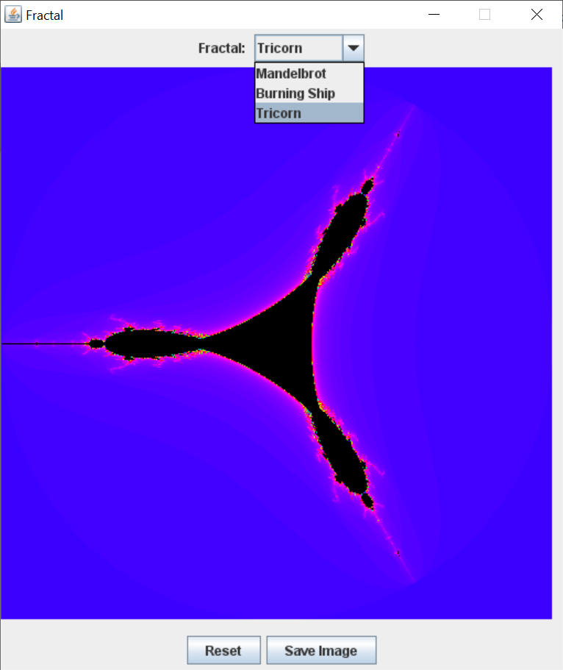

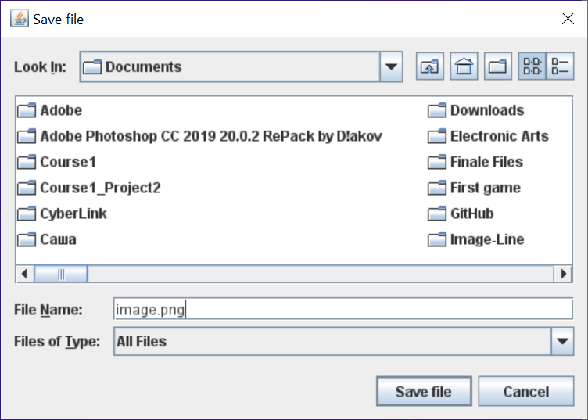

**Вывод:** добавила поддержку нескольких фракталов и реализовала возможность выбирать нужный фрактал из выпадающего списка, добавила поддержку сохранения текущего изображения в файл.